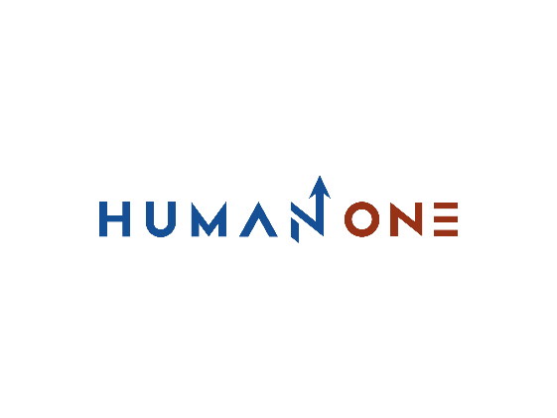

Services

Big Data & analytics

Platform Development

Expertise

**EN**

**FR**

Get in touch

Company

Cloud

DevOps

# **DevOps**



Let’s Talk

Our consulting services aim to keep your business on top of the ever-changing global market and inline with the latest technology trends. Our experts will support you at every step of solution and software development life cycle. To ensure predictability and efficiency, HumanOne handles technical challenges promptly by applying a systematic approach to advisory at both the enterprise and business architecture levels. Thanks to our extensive technical and process competencies, your breakthrough ideas will quickly turn into tangible business outcomes.

## DevOps consulting services: From strategy to action

**Continuous feedback**

Shape a better development vector for your product by automating the collection of insights for new user stories and incorporating those insights into future product releases

The way forward for all companies is marked by three longstanding software development goals: faster software deployments, universal code security, and top-level predictability for new functionality. As a DevOps company, our goal is to help you achieve all of these, no matter where you currently are on your DevOps journey. Whether you’re at level 1 or level 3 maturity, we can help you sustainably move at least two steps ahead. We’ll help you create a DevOps strategy formalizing your way towards your desired DevOps state and get hands-on with your current application development lifecycle. Step away from production chaos and move toward a structured development environment, optimized for frequent automated deployments of fully tested releases with minimal code churn.



**Platform maintenance & support**

Reduce the hassle of infrastructure configuration and prevent environment drift with infrastructure as code (IaC) solutions. Rapidly test new apps in production-like environments

**Continuous deployment**

Accelerate your deployment process with the optimal set of DevOps technologies. Eliminate error-prone and resource-heavy manual processes that are bogging down your operations

**Continuous Integration**

Improve the speed and quality of new feature development by automating code merges, sharing codebases, and introducing testing automation throughout the software development lifecycle





**Continuous monitoring**

Pair rapid releases with foolproof observability to measure everything that matters. Collect new insights for retrospective analysis to harness further operational improvements

**Configuration management**

Use automated tools and platforms to assemble and manage multiple systems. Automate updates, locate poorly performing configurations, and prioritize key actions faster

**Release Management**

Streamline the entire release process with multi-tier automation tools, scheduled jobs, and orchestration tools, helping your team run smooth rollouts sans disruption

Let’s start your platform development process

Get in touch

## **What other benefits do DevOps as a service companies offer?**

### **Automated quality assurance**

Automated testing is a core part of DevOps. However, that doesn’t mean your QA team will be left out. On the contrary, with the introduction of Continuous Integration and Continuous Testing, the roles and responsibilities of QA specialists will only grow in importance. Let’s re-imagine the role of quality assurance within your company together.

With manual testing out of the way, your QA engineers will have more time to focus on supporting the development team by providing them with the best-suited tools and testing strategies for various types of applications, integrations, and target deployment environments. With more time available for exploratory testing, your QA team can turn into an advisory unit, setting the right direction for further product quality and security enhancements. Our aim is to position your QA process to accelerate deployments instead of holding it back.

### **Cross-skilling improvements**

From Fortune 500 companies to pioneering market entrants, HumanOne provides PaaS consulting and digital platform development services to companies at different stages of their market and digital journeys. We know how to approach problems from unexpected angles and translate them into custom solutions for our clients.

Together, we’ll work on reducing your volume of unplanned work and unnecessary code rework so your core team can break away from the vicious fix–maintain cycle. As part of this procedural transformation, we’ll showcase how new tools, processes, and practices can positively contribute to your team’s day-to-day work and why shared responsibility is the way to go for higher work satisfaction. By simplifying coordination, approval, and general workflow stages, we’ll get your people excited about adopting new DevOps practices

### **Comprehensive security posture**

The core DevOps principles — downstream automated flows, continuous feedback, and continuous experimentation — are equally applicable to security. Thus, building a better DevOps culture also translates into a stronger security posture. HumanOne is among the few DevOps companies that place a strong emphasis on weaving security best practices into an upgraded application delivery lifecycle.

ShapeWith our guidance, you can achieve strong collaboration between development, operations, and security teams, all working cross-boundaries to get essential work done. Our consultants can advise you on the best security tools and practices to integrate into your development pipelines so your engineers can confidently do their work without worrying about hidden security problems. By investigating and fine-tuning your processes, we can help you build a new culture where security is a shared responsibility. Because what’s good for security is good for the end customer.

